Canopy Ownership Summary
Canopy Home Services, LLC

1. Entity Formation
Entity | Formation
Canopy Roofing, LLC | Arizona - effective July 23, 2023
Canopy Home Services, LLC | Delaware - effective April 27, 2023

2. Ownership of Canopy Home Services, LLC
Canopy Home Services, LLC owns Canopy Roofing, LLC and A Quality HVAC Services, LLC.
Member / Owner Entity | Ownership | Owner
RFH 2 LLC | 70.0% | Marcus Ridgway
RFH 1 LLC | 17.5% | Marcus Ridgway
Aspire, LLC | 7.0% | Ward Andrews
CBC HVAC Companies, LLC | 5.5% | Bryan Cary
Total | 100.0%
Ownership Structure
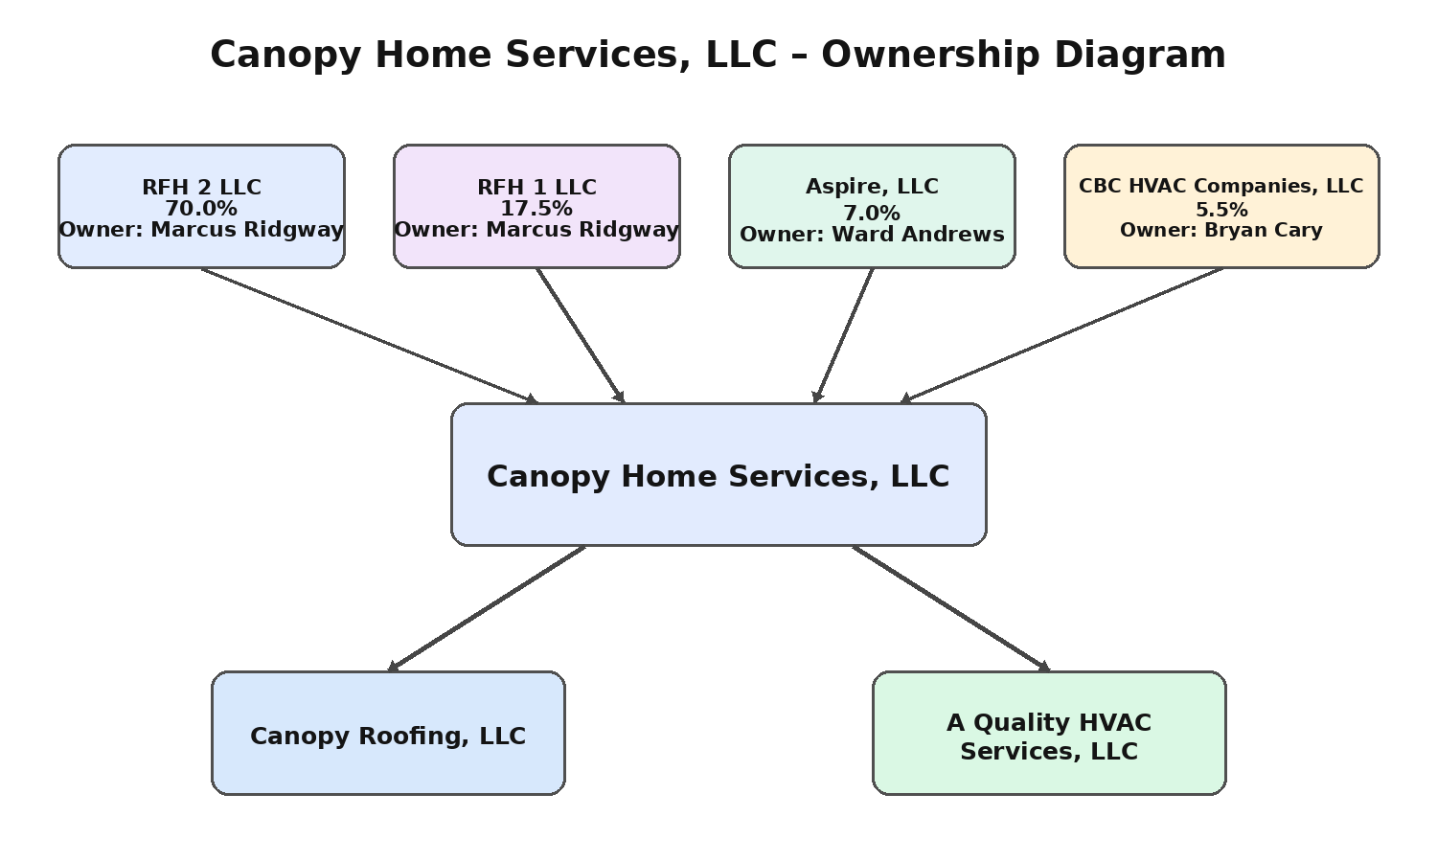

3. Owner / Contact Details
Entity / Entities | Owner | Mailing Address | Spouse
RFH 2 LLC / RFH 1 LLC | Marcus Ridgway | 6846 E. Monte Ave, Mesa, AZ 85209 | Keisa Ridgway
Aspire, LLC | Ward Andrews | 3040 E Inverness Ave, Mesa, AZ 85204 | Lisa Andrews
CBC HVAC Companies, LLC | Bryan Cary | 3992 N Evergreen St, Buckeye, AZ 85396 | Jennifer Cary

